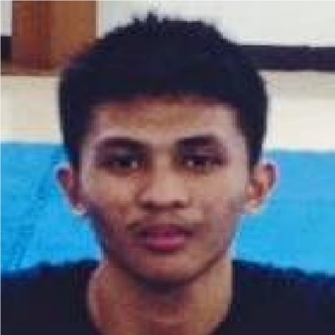

**CARL JOSHUA NORTE LAVARRO**

Lot 10 Blk 3 Bluestone Street, Km 18 Severina Diamond Subd, Parañaque City

carljoshua.lavarro@yahoo.com

09276152866

**EDUCATIONAL BACKGROUND:**

Tertiary

Asia Pacific College

Magallanes, Makati City

Bachelor of Science in Information Technology Major in Mobile and Internet Technology (undergraduate)

June, 2014-Present

Secondary

Ville Saint John Academy

Maharlika Ave. Phase V Marcelo Green Village Parañaque City

2006-2010

Elementary

Ville Saint John Academy

Maharlika Ave. Phase V Marcelo Green Village Parañaque City

2000-2006

**ORGANIZATIONS:**

MICROSOFT COMMUNITY- Events Member

APC PWERSA MMA - Member

JPCS - Member

**RELATED SKILLS:**

Web Designing

Programming Skills (Java, C++, HTML, PHP, SQL)

Technical Skills (MS Word, Excel, PowerPoint, Use of Internet search engines, Email)

**CHARACTER REFERENCES:**

Mr. Christian Fruto (Academic)

College Instructor

Asia Pacific College

09467553600

Mr. Alfredo Gregorio

Kagawad

Barangay Marcelo Green Village

09995001850